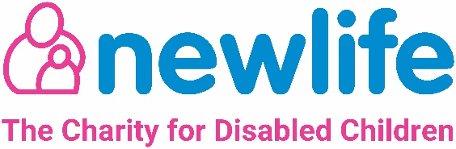

Volunteering Application Form
Name: | Title: Mr/Mrs/Miss/Ms/other
Telephone No:

Address:

Email:

How do you want to hear from us? Telephone / Email / Text / All

What sort of volunteering are you interested in?
At Newlife we have a wide variety of opportunities across our departments. Tell us a little bit about your skills and interests and we will help to match up a role for you.

Do you consider yourself to have a disability? Y / N

If you do consider yourself to have a disability, are there any reasonable adjustments which may need to be made to enable you to carry out your placement? Y/N Please give details of any adjustments required:

Availability
What availability do you have to volunteer?
 | Monday | Tuesday | Wednesday | Thursday | Friday | Saturday | Sunday
Morning
Afternoon
PHOTO CONSENT
To celebrate the positive benefits of volunteering, Newlife may take photos of activities for use on our web sites, social media, in the press or promotional materials. Please complete the photo consent declaration below. This agreement will remain effective until we are otherwise informed.

I do / do not give permission for photos to be taken and used by Newlife for promotional and publicity purposes.

To help us to offer you suitable roles, please supply details of two character references. Referees can be friends, employers, teachers or anyone that knows you well, other than a family member.

Reference 1 | Reference 2
Name: | Name
Address: | Address:
Telephone: | Telephone:
Email: | Email:
Relationship: | Relationship:

General Data Protection Regulation
We, Newlife the Charity for Disabled Children are the ‘controllers’ of the information which we collect about you. We are committed to protecting your personal data, whether it is sensitive or not, and we only process data if we need to for a specific purpose. Newlife’s People Team collect and process all personal data related to staff employment and volunteer engagement.

To see Newlife’s full Privacy notice, please visit:
https://newlifecharity.co.uk/privacy-policy/

N.B: Some volunteer roles may also require a Disclosure and Barring application (DBS, previously CRB). This is free for volunteers, and you will be informed if your role will require this.

Signed………………………………………. Date……………………………………

Please return this form completed to volunteer@newlifecharity.co.uk

Newlife the Charity for Disabled Children
Hemlock Way, Cannock. Staffordshire WS11 7GF
Tel: 01543 462777
www.newlifecharity.co.uk

